2026 Contest dates and times （文中的英文时间均为美东时间，+13小时即为北京时间）:
- Contest Starts: 5PM EST on Thursday, January 29, 2026 （北京时间1月30日凌晨6点）.
- Contest Ends: 8PM EST on Monday, February 2, 2026 （北京时间2月3日上午9点，在此之后不要修改论文）.
- Submission Deadline: 9PM EST on Monday, February 2, 2026 （北京时间2月3日上午10点，在此之前必须将论文提交）
- 注意
  - 1.今年竞赛结束和提交论文截止之间只有一小时.
  - 2. 今年提交方式有改动（见下文）
- Contest Results: The results will be posted on May 8, 2026. （出结果：5月8日，往年实际时间在4月底到5月中之间）
提交网址：
https://forms.comap.org/241335097294056
Advisor ID: 128224
Control ID: 每队不同，见共享文档
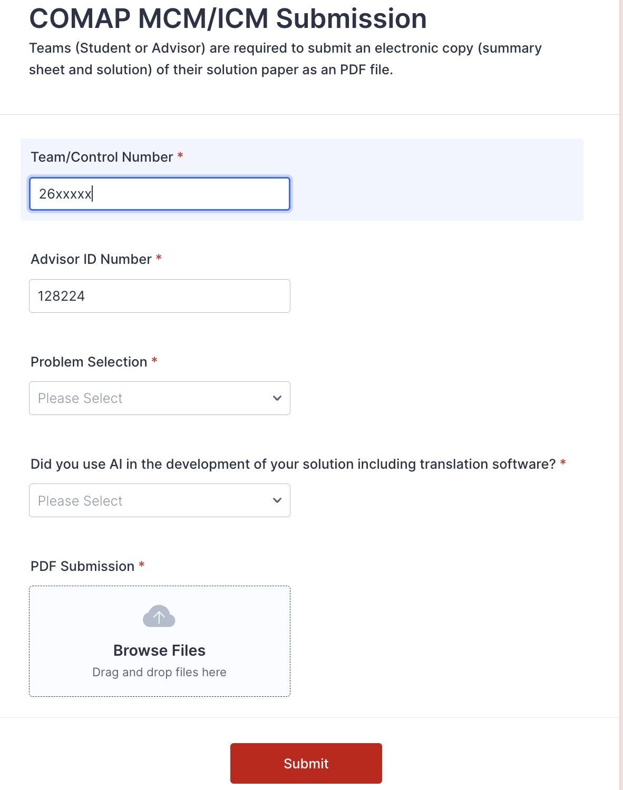
选题：在群里共享的腾讯文档中选好题目，建议在北京时间周六（1.31）之前完成，尽量不要换题。
IMPORTANT NOTES:
- COMAP is the final arbiter of all rules and policies, and may disqualify or refuse to register any team that, in its sole discretion, does not follow these contest regulations and procedures.
- Decisions of the judges, the contest directors, and the editor of The UMAP Journal are final.
- If a team is caught violating the rules, the faculty advisor will not be permitted to advise another team for one year, and the advisor’s institution will be put on probation for one year. （请注意不要作弊，否则可能影响整个学校）
- If a team from the same institution is caught violating the rules a second time, then that school will not be allowed to compete for a period of at least one year.
- All times given in these instructions are in terms of Eastern Standard Time (EST). (COMAP is located in the U.S. Eastern Time zone.)
NEW Changes in recent years
NEW During the Contest - Use of Large Language Models and Generative AI Tools in COMAP Contests
This policy is motivated by the rise of large language models (LLMs) and generative AI assisted technologies. The policy aims to provide greater transparency and guidance to teams, advisors, and judges. This policy applies to all aspects of student work, from research and development of models (including code creation) to the written report. Since these emerging technologies are quickly evolving, COMAP will refine this policy as appropriate.
Teams must be open and honest about all their uses of AI tools. The more transparent a team and its submission are, the more likely it is that their work can be fully trusted, appreciated, and correctly used by others. These disclosures aid in understanding the development of intellectual work and in the proper acknowledgement of contributions. Without open and clear citations and references of the role of AI tools, it is more likely that questionable passages and work could be identified as plagiarism and disqualified.
Solving the problems does not require the use of AI tools, although their responsible use is permitted. COMAP recognizes the value of LLMs and generative AI as productivity tools that can help teams in preparing their submission; to generate initial ideas for a structure, for example, or when summarizing, paraphrasing, language polishing etc. There are many tasks in model development where human creativity and teamwork is essential, and where a reliance on AI tools introduces risks. Therefore, we advise caution when using these technologies for tasks such as model selection and building, assisting in the creation of code, interpreting data and results of models, and drawing scientific conclusions.
（允许使用AI工具写论文，但要了解AI工具产生的语言不一定完全正确且有plagiarism风险，另外需要明确说明使用状况）
Guidance for teams
Teams are required to:
1. Clearly indicate the use of LLMs or other AI tools in their report, including which model was used and for what purpose. Please use inline citations and the reference section. Also append the Report on Use of AI (described below) after your 25-page solution.
2. Verify the accuracy, validity, and appropriateness of the content and any citations generated by language models and correct any errors or inconsistencies.
3. Provide citation and references, following guidance provided here. Double-check citations to ensure they are accurate and are properly referenced.
4. Be conscious of the potential for plagiarism since LLMs may reproduce substantial text from other sources. Check the original sources to be sure you are not plagiarizing someone else's work.
Citation and Referencing Directions
Think carefully about how to document and reference whatever tools the team may choose to use. A variety of style guides are beginning to incorporate policies for the citation and referencing of AI tools. Use inline citations and list all AI tools used in the reference section of your 25-page solution. Whether or not a team chooses to use AI tools, the main solution report is still limited to 25 pages. If a team chooses to utilize AI, following the end of your report, add a new section titled Report on Use of AI. This new section has no page limit and will not be counted as part of the 25-page solution.

The MCM/ICM Contest now have a 25 page limit. The 25 page limit applies to the entire submission including the Summary Sheet, Solution, Reference List, Table of Contents, Notes, Appendices, Code and any problem specific requirements. （页数限制为25页，包括总结页、正文、参考文献、目录、附录、注释、代码、及题目要求的其他内容，不包括AI使用报告）

Contest Rules
- Each team may consist of a maximum of three undergraduate (or below) students enrolled full- or part-time at the same school/institution （明确不能跨校组队） at the time of the contest. Teams may consist of 1, 2, or 3 students and each student may only participate on one team.
- Each team must have an advisor who is a staff member, a faculty member, or a student at the team members’ institution.
- Not later than the opening of the contest window, advisors must assign team members to a particular team, and cannot add or change student assignments for the duration of the contest. Teams may, however, remove a team member, if he or she decides not to participate.
- Once the contest window opensteam membership must be set and teams may not use any persons, other than their own team members, to discuss or obtain ideas for working on and solving their problem. Teams may use any "inanimate" resource they find on their own such as: web pages, books, articles, research reports, databases, etc. Teams may not seek help in obtaining answers, ideas, or information, or in locating appropriate resources, from any persons outside of their team to include their advisor, other teachers, other students, and/or experts or professionals in a field relevant to the problem. This restriction includes personal or telephonic contact, as well as use of electronic social media such as, but not limited to: emails, texting, chat rooms, question-answer systems, interactive blogs, Twitter, Weibo, online help or support sites, etc. （明确不能与队伍之外的人交流题目相关内容） Additionally, posting or sharing any part or all of the problem statement, your team’s solution process, or any partial or complete work in any form or medium during the contest is strictly prohibited（不要把论文交给队伍之外的人，包括修改查重服务等）. COMAP will disqualify or deem unsuccessful any team that violates this rule. The relevant issue is one of intent: each team of students is expected to develop all of its substantive analysis and solution without the help of others.
- Teams must document any outside sources of information by using footnotes, endnotes, or in-line documentation, and include appropriate citations in a reference list or Bibliography of these sources. （注意引用）
- Teams choose to work on one problem (MCM: A, B, or C or ICM: D, E, or F) and submit one solution for the problem of their choice.
- The names of the students, advisor, and/or institution must not appear on any page of the solution. The solution must not contain any identifying information other than the team Control Number.（除了控制号，不要出现任何个人或学校信息）
- Papers must be submitted as an Adobe PDF electronic file （不能交word，不要单独交代码或图表）, and typed in English （不要出现任何中文）, with a readable font of at least 12-point type. Papers must be within the 25 page limit. （页数限制为25页）
- COMAP follows all accommodations relative to learning conditions for individual students used as part of the local school/institution program in an affected student's daily learning. If specialized staff is required, the school bears the responsibility for providing any specialized assistance as required by law. If such accommodations are required for a student participating, the school should detail them and the extent to which they were utilized as part of the MCM/ICM activities.
- COMAP reserves the right to disqualify or reduce the award level of teams found to have violated the contest rules.
Contest Tips
Before the Contest - Preparing a Team
We encourage advisors and faculty to coach and prepare students BEFORE the start of the contest. COMAP offers several resources:
a. Go to the MCM/ICM web site and review the rules, guidelines, and prior years' problems.
b. Visit www.mathmodels.org to view previous years' problems and solutions.
c. Visit https://www.comap.com/undergraduate/contests/resources/index.html, the MCM/ICM Articles, Resources, and Links page.
d. The MCM/ICM "Tips" article (found on the resource web page) provides students and advisors tips for before, during, and after the contest.
e. Read the Summer and Fall UMAP Journal MCM and ICM articles, which include the Director's Article and Judges' Commentary for MCM and ICM. These articles describe what judges look for in the various sections of solutions.
Ensure that students have access to computers that enable them to word process, use a spreadsheet, and dynamically model both graphs and geometric relationships.

During the Contest - Choosing and Solving the Problem
The contest problems will become available at
https://www.comap.com/undergraduate/contests/mcm
http://www.comapmath.com/MCMICM/index.html
http://www.comap-math.com/mcm/index.html
http://www.mathportals.com/mcm/index.html
http://www.immchallenge.org/mcm/index.html
If you cannot access any of the sites, there may be a problem with your local Internet connection. Contact your local Internet service provider to resolve the issue. with your local Internet connection. Contact your local Internet service provider to resolve the issue.
Each registered team may choose any one of the six problem choices and should submit a solution to only one problem.
• MCM problems are Problem A, Problem B or Problem C.
• ICM problems are Problem D, Problem E or Problem F.
Teams may use any inanimate source of data, materials, computers, software, references, websites, books, etc. Teams should reference all sources used using footnotes, endnotes, or in-line documentation, and include an associated reference list citing all sources.
Teams may not seek help from any person outside of team members as delineated in the Contest Rules (specifically Rule #6).
Teams should keep in mind the following guidelines when solving the problem and developing their solution.
a. Summary Sheet: The summary is an essential part of your MCM/ICM paper and should appear as the first page of your solution report. The judges place considerable weight on the summary, and winning papers are often distinguished from other papers based on the quality of the summary.
Click here to download the Microsoft Word Summary Sheet or Click here to download the LaTeX Summary Sheet.
• To write a good summary, imagine that a reader will choose whether to read the body of the paper based on your summary: Your concise presentation in the summary should inspire a reader to learn about the details of your work.
• You should write the summary last, as it should clearly describe your approach to the problem and, most prominently, your most important conclusions. Ensure you plan time after solving your problem to write a comprehensive and articulate summary.
• Summaries that are mere restatements of the contest problem, or are a cut-and-paste boilerplate from the Introduction are generally considered to be weak.
b. Overall: The team’s solution should be articulate, concise, and organized in order to allow the reader to easily follow the solution process and conclusions. Key statements should present major ideas and results.
• A Table of Contents assists the reader in previewing the organization of your report.
• Present a clarification or restatement of the problem as appropriate.
• Present a clear exposition of all variables and hypotheses.
• State and justify reasonable assumptions that bear on the problem.
• Present an analysis of the problem, motivating or justifying the model being used.
• Summarize derivations, computations, or illustrative examples in the main body of the solution, and leave lengthy derivations and/or calculations and data in appropriate appendices.
• Include a design of the model. Discuss how the model could be tested, to include error analysis, sensitivity, and/or stability.
• Discuss any apparent strengths or weaknesses to your model or approach.
• Provide a conclusion and report results explicitly.
• Document resources and references.
New! Follow COMAPMath on Twitter or COMAPCHINAOFFICIAL on Weibo for the most up to date information before, during, and after the contest.
During the Contest – Preparing a Solution Document
MCM/ICM solutions are judged as varying degrees of successfully completing the contest (from Successful Participant up to Outstanding). There is no passing or cut-off score, and therefore, partial solutions are acceptable and teams are encouraged to complete as much of the problem as they are able to do. MCM/ICM judges are primarily interested in the team’s thought processes, analysis of the problem, modeling approaches, and mathematical methods.
Teams must submit their entire solution in one Adobe PDF electronic file, consisting of written text, figures, charts, and supporting materials. Papers must be typed in English, with a readable font of at least 12-point type. Do not send additional “non solution” files such as data or computer programs.
Each page of the solution must contain the team control number and the page number at the top of the page. Use a page header on each page - for example: Team # 2614321, Page 6 of 25.
Your solution report should start with the Summary Sheet followed by the team’s solution. Ensure your solution meets the 25 page limit requirement. A Table of Contents is encouraged and does count toward the page limit. Reference list (or Bibliography), notes pages, and any appendices now count toward the page limit and should be included after the solution pages.
Clearly indicate the use of LLMs or other AI tools in your report, including which model was used and for what purpose. Please use inline citations and the reference section. Also append the Report on Use of AI (described here) after your 25-page solution. This new section has no page limit and will not be counted as part of the 25-page solution.

Click here to download the COMAP AI contest policy with examples.
Names of the students, advisor, and/or institution must not appear on any page of the solution. The solution file must not contain any identifying information other than the team Control Number.
STOP making any changes to the solution at 8:00pm EST on Monday, February 2, 2026.

After the Contest - Submitting a Solution Document
- Teams must end all work on their solution by 8:00 p.m. EST on Monday February 2, 2026, and send an Adobe PDF electronic file of its Solution Paper to COMAP by 9:00 p.m. EST on Monday, February 2, 2026. *Note: Do not wait until the last minute. Send your solution as soon as it is completed and only send one copy （根据往年经验，如果交了多份，只有第一份会被评分）.
- No further modifications, enhancements, additions, or improvements may be made to the team's solution paper after 8:00 p.m. EST on February 2, 2026. Any changes to the solution will constitute a violation of the contest rules and may result in disqualification.
- Each team is required to submit an Adobe PDF electronic copy of its solution using the new online submission page https://forms.comap.org/241335097294056. Any team member or the advisor may submit the PDF submission.
A. You will need your team's control number, advisor id number and your problem choice to complete your submission.
B. Your electronic PDF solution file MUST be received at COMAP on or before the submission deadline of 9:00 p.m. EST on February 2, 2026 .
C. Use your team's control number as the name of your PDF file attachment. For example: 0000000.pdf. *Note: The attachment must be less than 20MB. （PDF文件名为控制号）
D. Page 1 of the team's PDF electronic solution should be the team summary, followed by the solution and any references and appendices. （顺序：summary、正文、reference、appendix、AI report）
E. Do not include or send programs, software, databases, and/or other files with your solution, as they will not be used in the judging process. （源代码源数据没有用，不要交）
F. The names of the students, advisor, or institution should NOT appear on any page of the electronic solution. （不准出现个人或院校信息）
G. COMAP will accept only an Adobe PDF of your solution. Limit one solution per submission form.
- Failure by a team to submit a solution via submission form by 9:00 p.m. EST on February 2, 2026 in accordance with the above instructions may result in disqualification or reduction of award level.

NOTE: By submitting a MCM/ICM contest entry document, team members agree that:
• Their submission and all rights to its publication become the property of COMAP, Inc.
• COMAP may use, edit, excerpt, and publish this submission for promotional use or any other purpose, including placing it online, distributing it electronically, or publishing it in The UMAP Journal or otherwise, without compensation of any kind.
• COMAP reserves the right to use in materials relating to this contest, the names of the team members, their advisor(s), and their affiliations, without further notification, permission, or compensation.
• All images, figures, photographs, tables, and drawings in a team’s submission were either created by the team, or, if reproduced or obtained from another source, the submission cites a specific reference for each at its location in the submission.
• All direct quotations in the submission are enclosed in quotation marks or otherwise identified as such, with a specific reference cited for each at its location in the submission.

建议可以参考往年优秀论文
https://github.com/dick20/MCM-ICM

